Monitoring Data Website Guidance Document

The purpose of this document is to provide guidance on how to properly report quarterly monitoring data on the Monitoring Data Website (MDW).

Table of Contents

Important Information Regarding the Monitoring Data Website (MDW) 2
Login Instructions 2
Account Settings 3
Basic User Instructions 4
Submitting Water Withdrawal Data via Online Calendar 5
Submitting Water Withdrawal Data via Paste from Spreadsheet 7
Submitting Groundwater and Elevation Data 11
Submitting Passby Data via Paste from Spreadsheet 14
Submitting Master Source List Data (Total CU) via Paste from Spreadsheet 17
View Report Submission Status 20
Print Invoice 20
Example of Invoice 21
Print or Review Monitoring Data 22
Review Withdrawal Exceedance Data 23
Review Passby Data and Exceedances 24
Download Dockets 24
Help and Support 25

235954.1
Important Information Regarding the Monitoring Data Website (MDW)
The MDW is configured to operate over a Secure Sockets Layer (SSL). SSL cannot be used for Internet communications outside the United States. All MDW submissions must occur from within the United States.

The MDW requires that JavaScript be enabled on the Web browser. If JavaScript is disabled, the site will not work.

When a user is logged into the MDW, a session is created for them. This session will expire after 120 minutes, and can cause various parts of the MDW to generate errors. Users should be instructed to log out and then log back into the MDW should this occur.

Login Instructions
The MDW can be accessed from https://services.srbc.net/reporting. You can also find a link on the SRBC home page www.srbc.net.

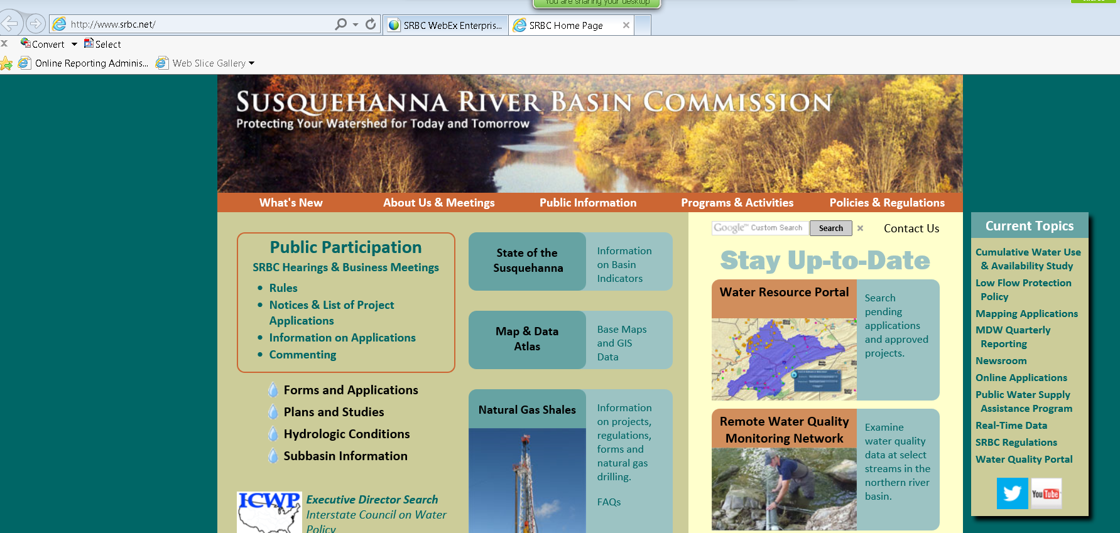

Log into the MDW using your assigned Username and Password.

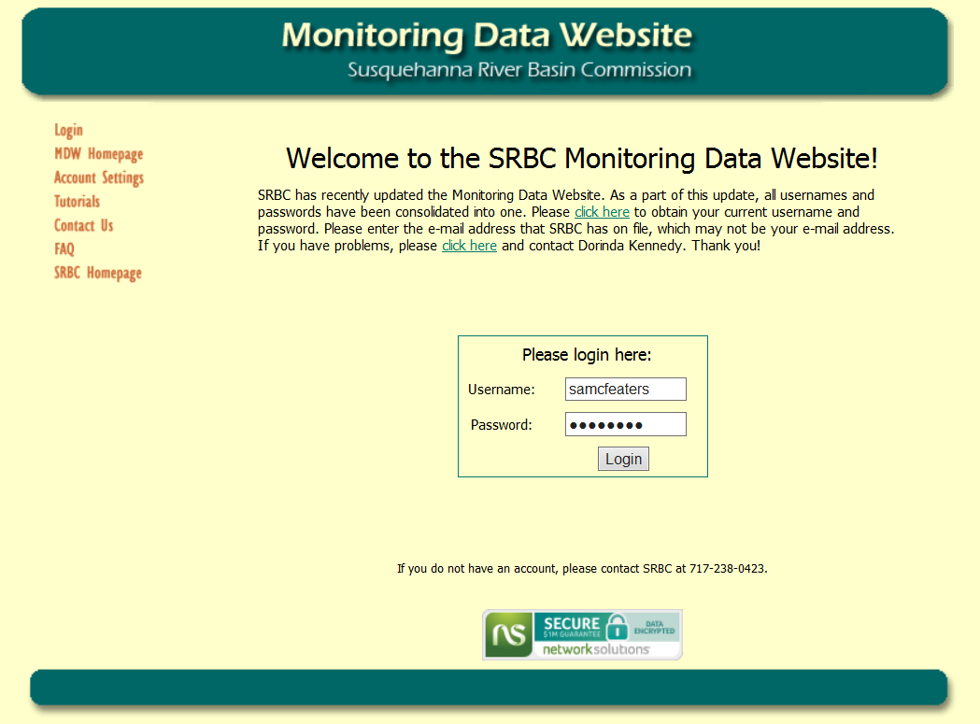
235954.1
If you forget your login information or password, you should attempt to login once and, upon failure, you will be given a link which you can use to recover your password. If you have an e-mail address on file, you simply need to enter that e-mail address, click “Submit” and your password will be e-mailed to you.

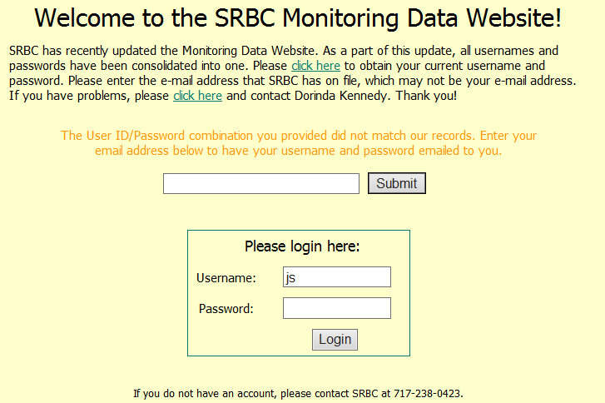

Account Settings
You can update the e-mail address and password stored on file by clicking on “Account Settings”. After logging in, you can enter your e-mail address or new password in the space provided, then click “Save”. You cannot delete an e-mail address once one has been added.

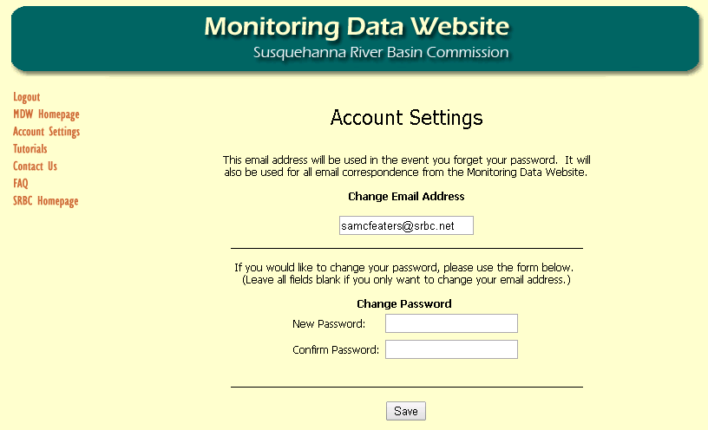

235954.1
Basic User Instructions
Upon login, you will see the welcome screen for the MDW. You will be given the options to Submit Usage Data, Submit Passby Data, Review and/or Submit Post-Hydrofracture Reports, View Report Submission Status, Print Invoices, Print or Review Historical Monitoring Data/Exceedances, Print or Review Historical Passby Data/Exceedances, and Download Dockets. These will be detailed below.

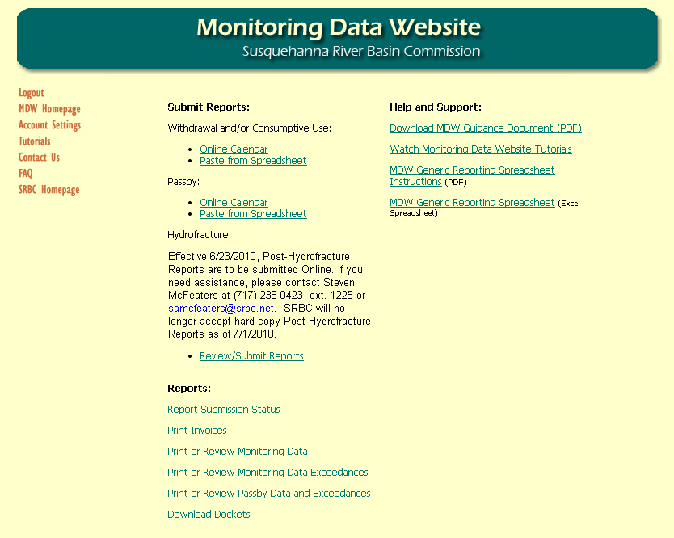

235954.1
Submitting Water Withdrawal Data via Online Calendar
On this page, you must first select a Facility.

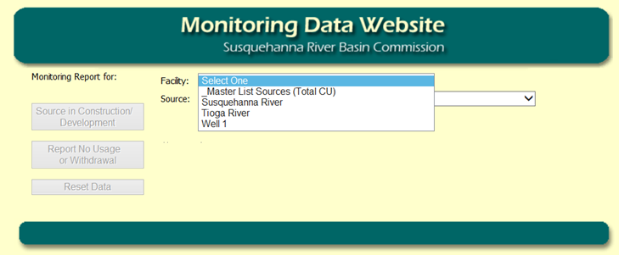

After you have selected your Facility, you must then select a Source.

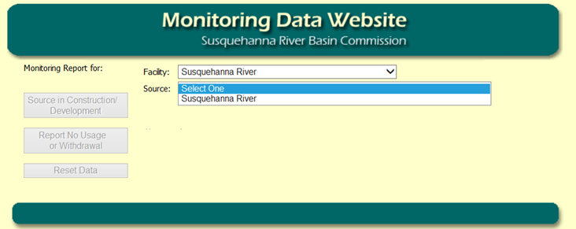

The submission calendar will load. You will select a day by clicking on it, enter your usage for the selected day in the dialog that appears, then click “Store”. You cannot enter values greater than zero for future dates.

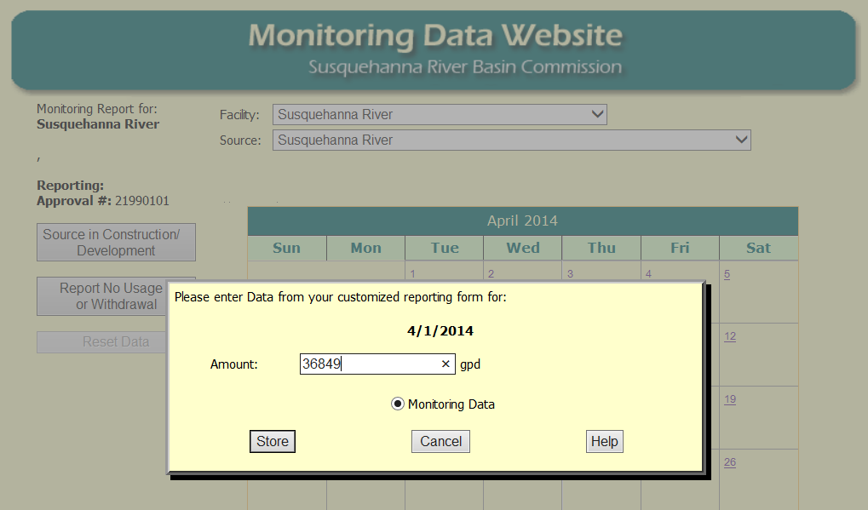

235954.1
If your site is under construction or you did not withdrawal any water for an entire month, you may click the appropriate button on the left hand side of the screen before choosing the appropriate month and “Continue”.

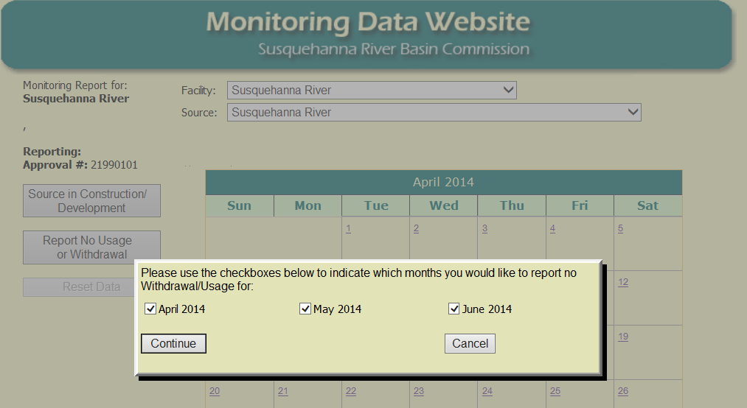

At the bottom of the review page there is a checkbox which must be checked, and a textbox in which you must enter your name prior to clicking “Submit”. You may also provide any comments that you feel necessary at this time. Note that the MDW will not accept punctuation when entering your name.

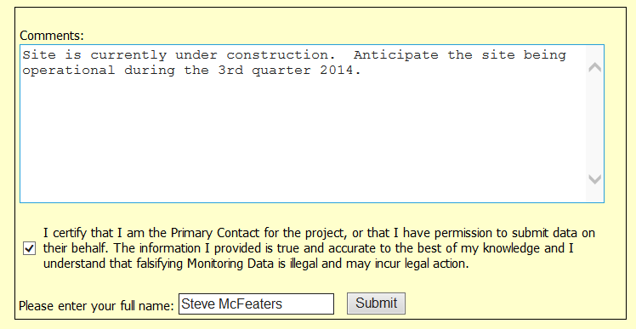

After you have submitted your withdrawal data, a summary of your submission status will be shown.

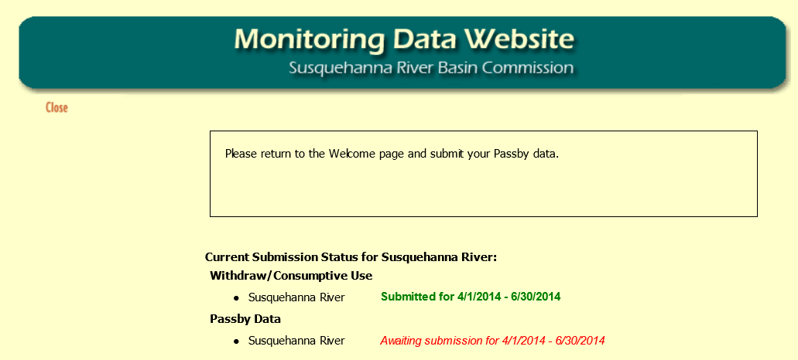
235954.1
Submitting Water Withdrawal Data via Paste from Spreadsheet
On this page, you must first select a Facility.

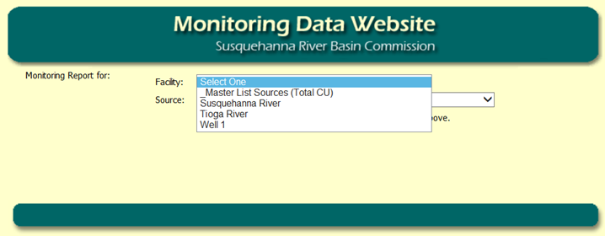

After you have selected your Facility, you must then select a Source.

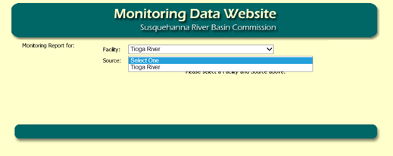

This will bring up a reporting page for you to paste Excel data, and some instructions about what information to paste. The heading of the box will show the date range of data that is expected.

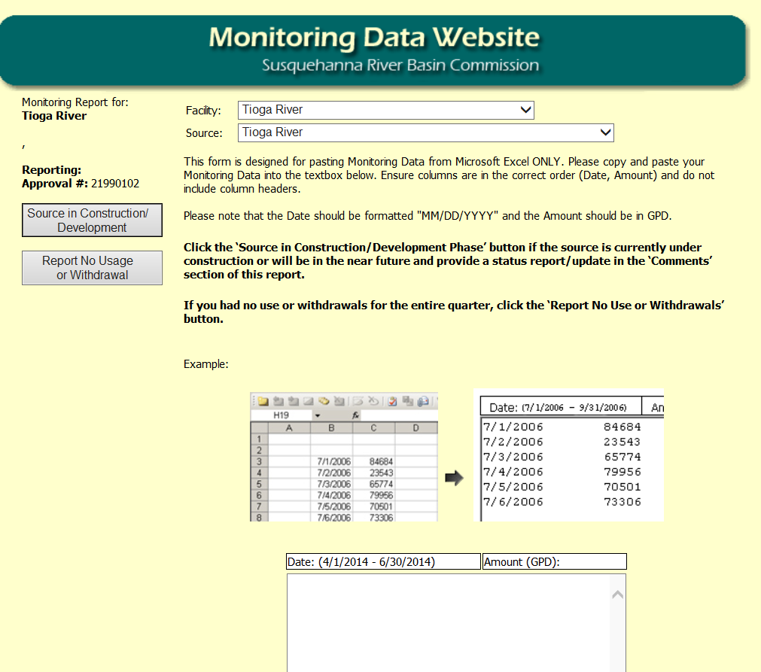

235954.1
You should copy the date and daily withdrawal amount (in Gals/Day) as shown in the simple example below. The column headers should not be copied. Note that the MDW does not accept commas, negative numbers or decimal numbers.

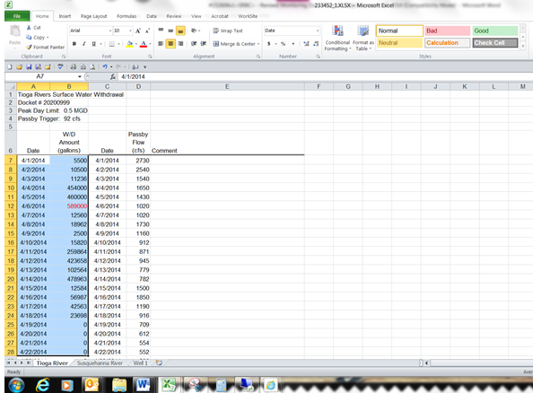

This information is then pasted into the reporting page in your web browser. It will appear as two columns of data.

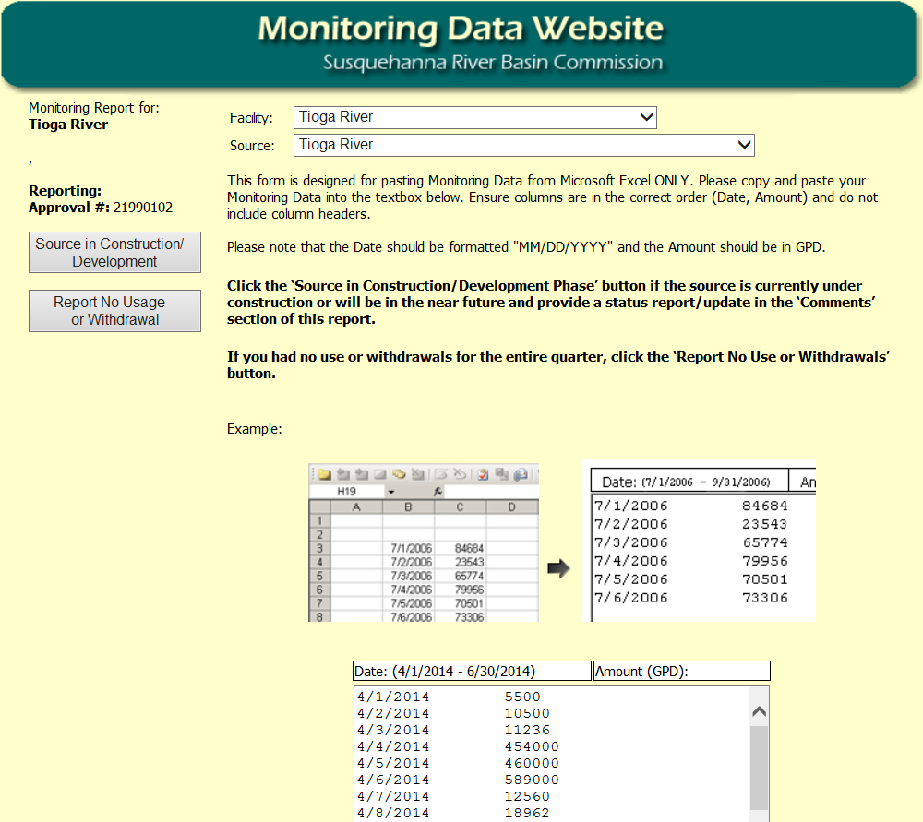

235954.1
After clicking “Preview” at the bottom of the page, a review screen will appear that shows the data that was just pasted. If there are any errors detected, a message will appear next to that entry with the problem description. For example, this screen indicates errors for negative numbers and entries that are not numeric. This data should be reviewed to ensure information is accurate and entered correctly. Should you encounter errors, click on the “Click Here” link to try again.

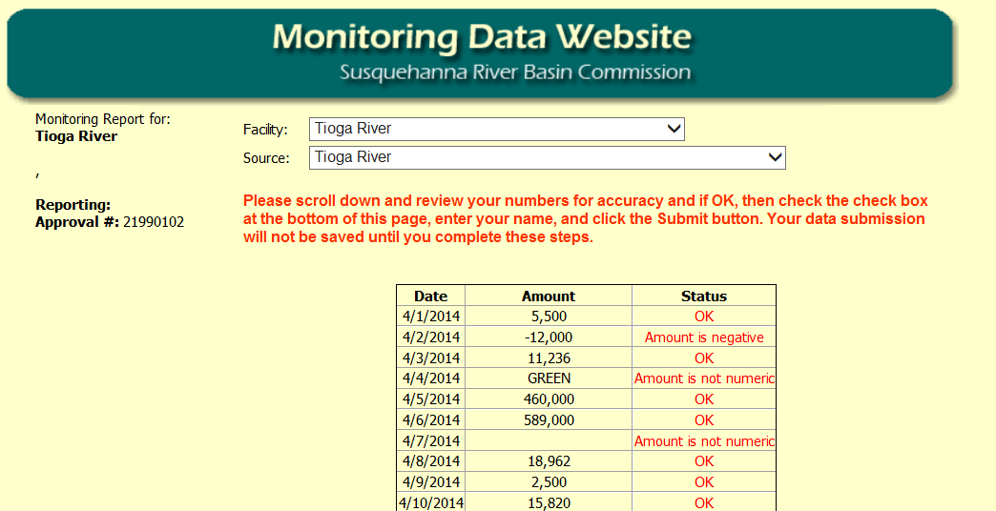

At the bottom of the review page there is a checkbox which must be checked, and a textbox in which you must enter your name prior to clicking “Submit”. Note that the MDW will not accept punctuation when entering your name.

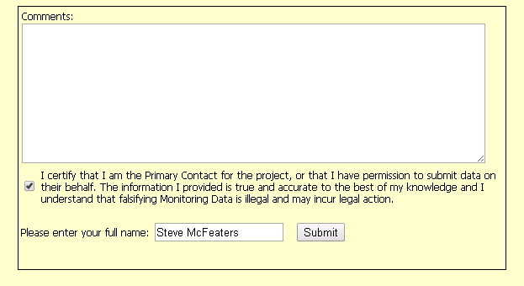

235954.1
Once withdrawal data has been submitted, your data will be reviewed for exceedances. If applicable, you will be required to enter a comment to briefly explain the reason for the exceedance. Note that if there were no exceedances, you will not see this page.

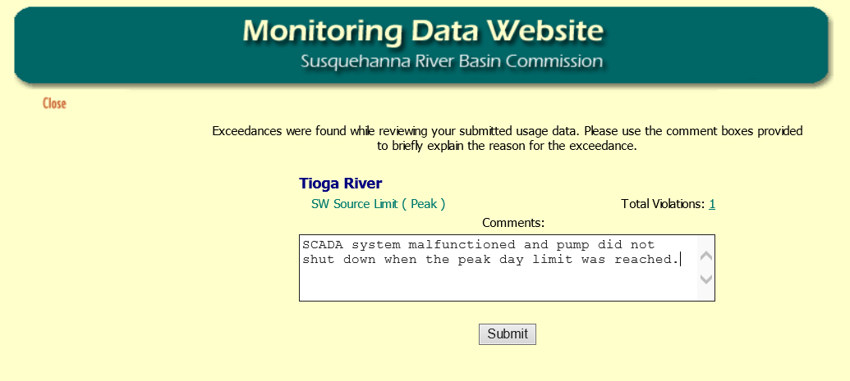
Click here to see a list of exceedances.
Once you have entered comments for all exceedances, you must hit the submit button.

After you have submitted your withdrawal data and an explanation for any exceedances, a summary of your submission status will be shown.

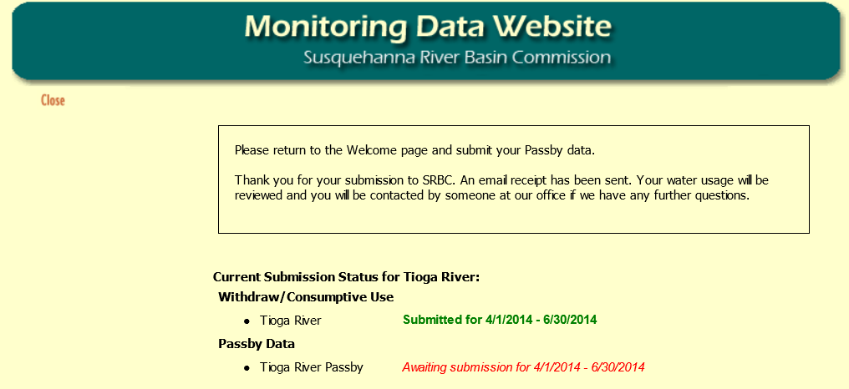

235954.1
Submitting Groundwater Withdrawal and Elevation Data
Groundwater withdrawal data shall be submitted in the same manner as surface water withdrawal data. You will start by selecting a Facility.

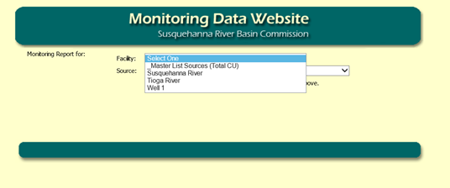

After you have selected your Facility, you must then select a Source.

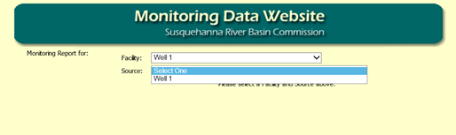

If you are also subject to entering groundwater elevation data for your source, you can paste this information into the reporting page as well. It will appear as three columns of data to include the water level. You should copy the date, daily withdrawal amount (gallons/day), and groundwater elevation (feet above mean sea level) as shown in the simple example below. The column headers should not be copied. Note that the MDW does not accept commas, negative numbers or decimal numbers.

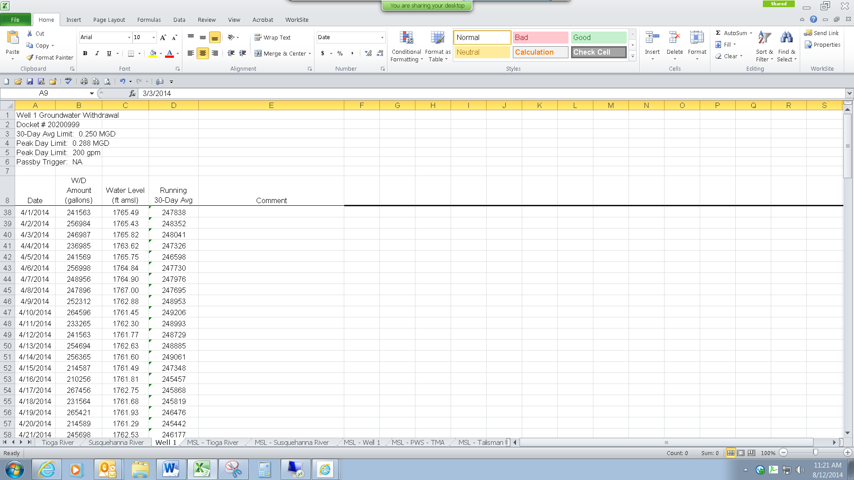

235954.1
This information is then pasted into the reporting page in your web browser. It will appear as three columns of data.

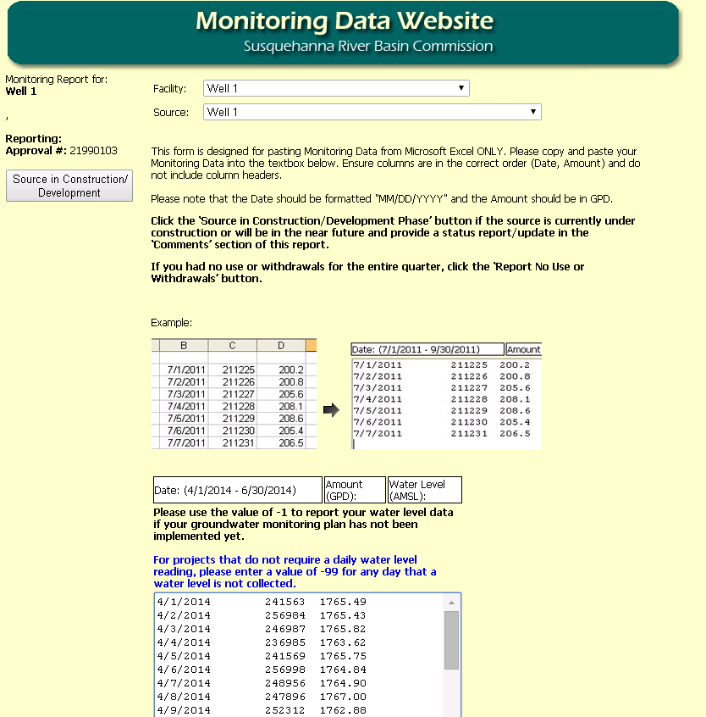

After clicking “Preview” at the bottom of the reporting page, a review screen will appear that shows the data that was just pasted. At the bottom of the review page there is a checkbox which must be checked, and a textbox in which you must enter your name prior to clicking “Submit”. Note that the MDW will not accept punctuation when entering your name.

235954.1
Once groundwater withdrawal data has been submitted, your data will be reviewed for exceedances. If applicable, you will be required to enter a comment to briefly explain the reason for the exceedance. Note that if there were no exceedances, you will not see this page.

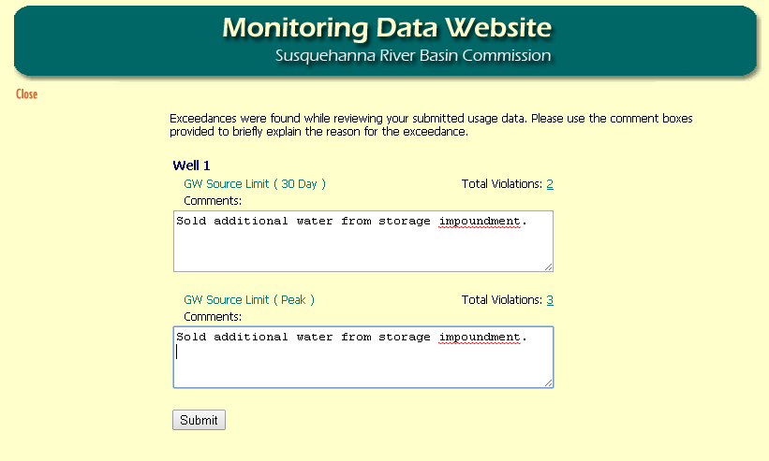
Once you have entered comments for all exceedances, you must hit the submit button.
Click here to see a list of these exceedances.

By clicking on the number of total violations, a detailed list of the exceedances will be provided.

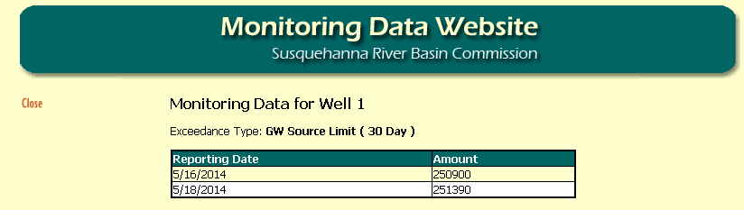

After you have submitted your withdrawal data, you will receive a confirmation message.

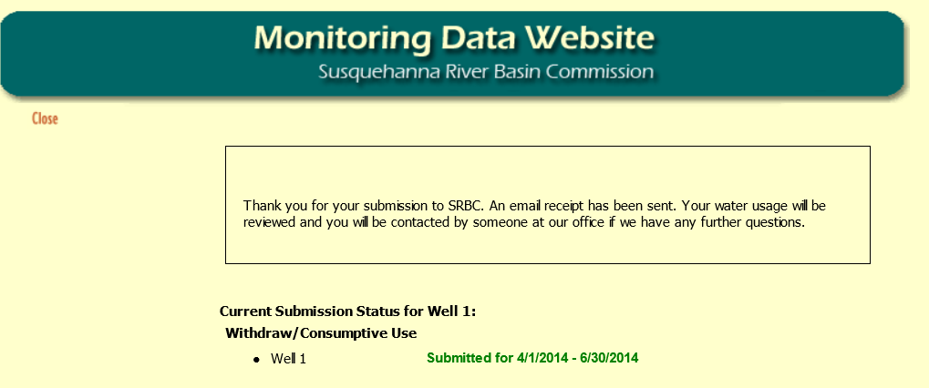

235954.1
Submit Passby Data via Paste from Spreadsheet
Once you have entered your withdrawal data, you must enter your passby data (even if you did not make a withdrawal). You must select your Facility and the Passby location that you wish to report.

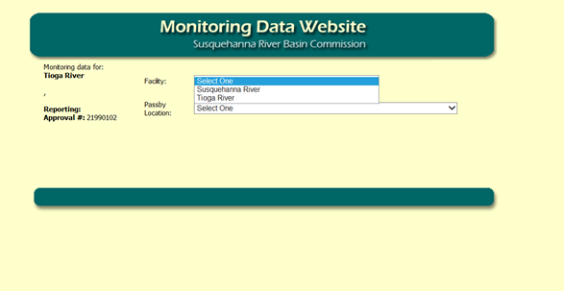

You may paste your data from an excel spreadsheet or if you had no withdrawals for the entire quarter, you may select “Report No Withdrawal” or “Report Off Season/Not Operational”.

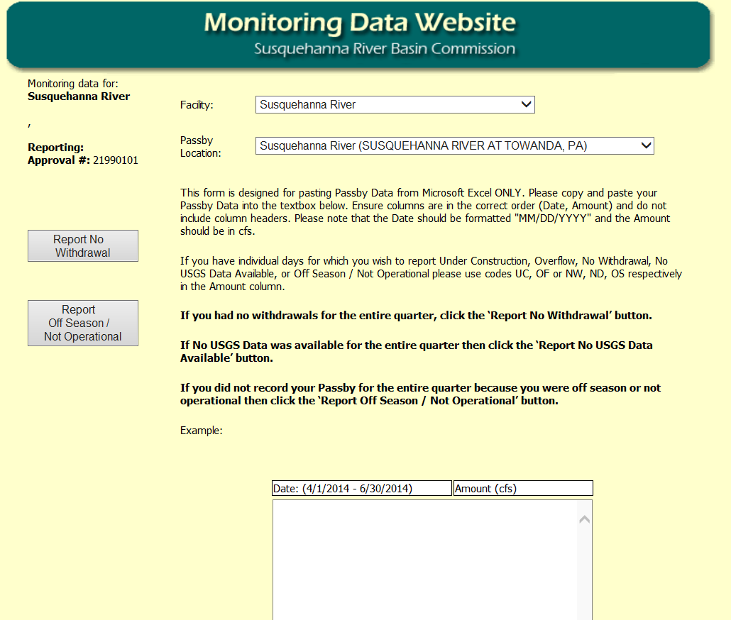

235954.1
If you had withdrawals during the reporting period, you must enter stream flow values. Please note, you will not have the option to “Report No Withdrawal” or “Report Off Season/Not Operational”.

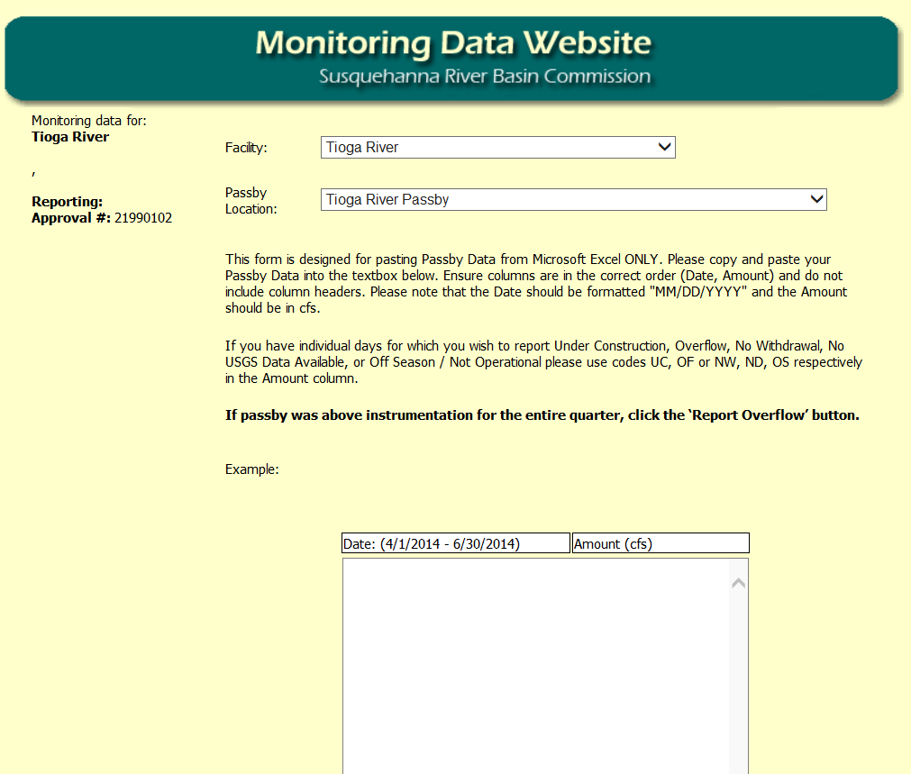

Once passby data has been submitted, your data will be reviewed for exceedances. If applicable, you will be required to enter a comment to briefly explain the reason for the exceedance. Note that if there were no exceedances, you will not see this page.

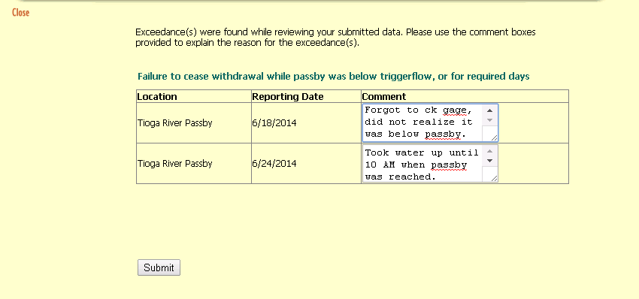
Once you have entered comments for all exceedances, you must hit the submit button.

235954.1
After you have submitted your passby data, you will receive a confirmation message.

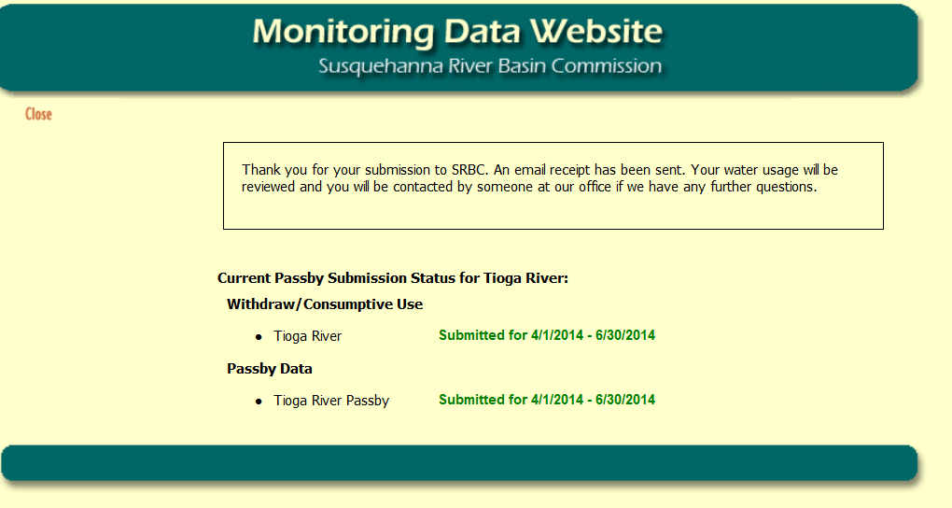

As indicated in the text box on the confirmation page, you will also receive an e-mail notification of your submittal.

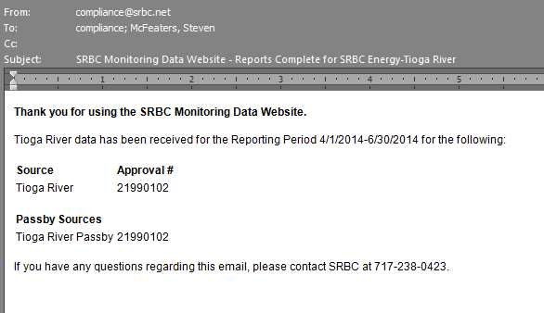

235954.1
Submitting Master List Sources Data (Total CU) via Paste from Spreadsheet
On this page, you will select Master List Sources (Total CU) as your Facility and then select which Source you would like to report.

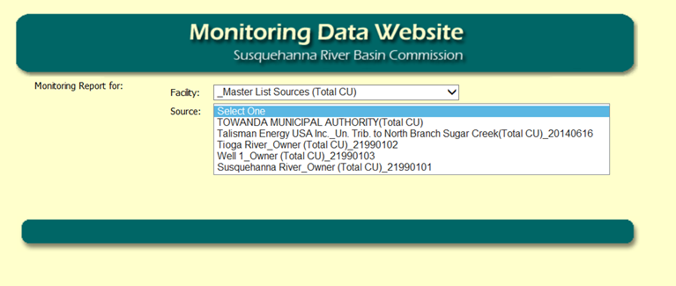
Please note that the Master List includes both sources that you own and those registered as a shared source.

This will bring up a reporting page for you to paste Excel data, and some instructions about what information to paste. The heading of the box will show the date range of data that is expected.

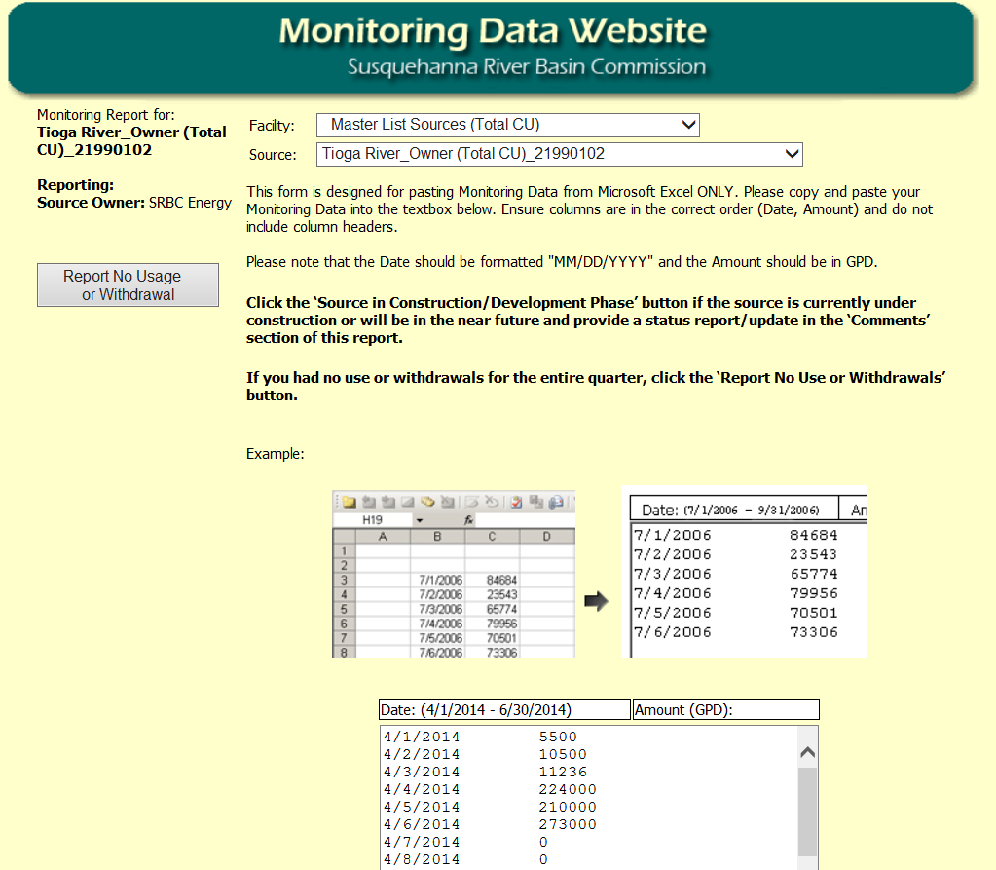

235954.1
After pasting the data and clicking the preview button at the bottom of the page, a review screen will appear that shows the data that was entered. If there are any errors detected, a message will appear next to that entry with the problem description. This data should be reviewed to ensure information is accurate and entered correctly. Should you encounter errors, click on the “Click Here” link to try again.

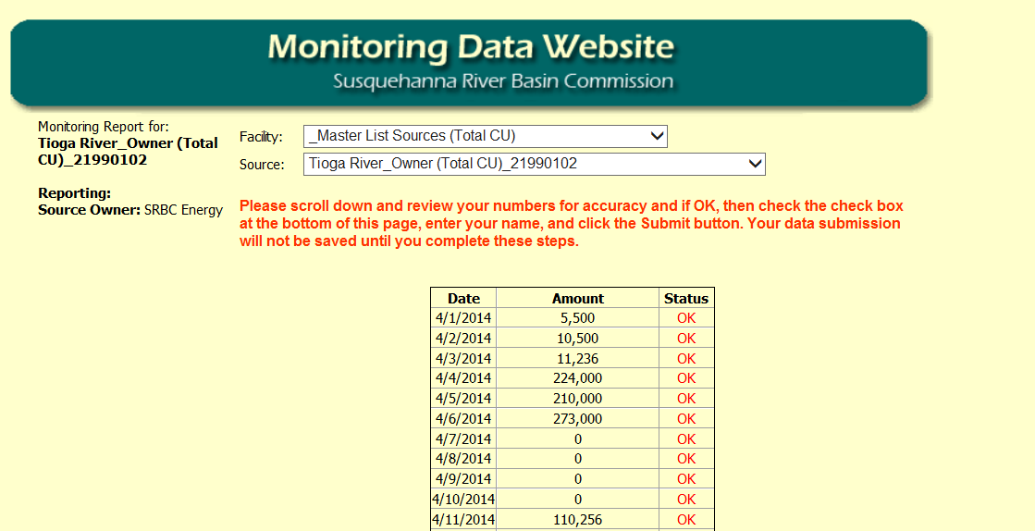

At the bottom of the review page there is a checkbox which must be checked, and a textbox in which you must enter your name prior to clicking “Submit”. Note that the MDW will not accept punctuation when entering your name.

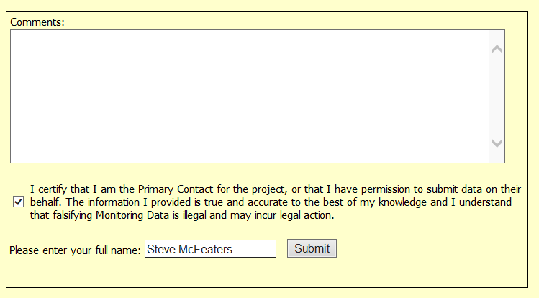

235954.1
Once data has been submitted, a summary of your submission status will be shown, unless this is the last source you are submitting.

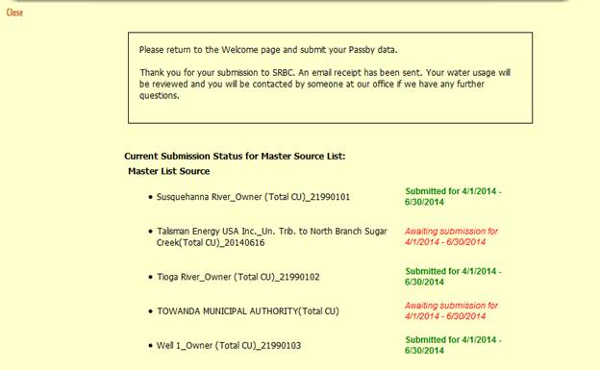

After you have submitted your Total CU for all the sources on your Master List, you will receive a confirmation message. As indicated in the text box on the confirmation page, you will also receive an e-mail notification of your submittal.

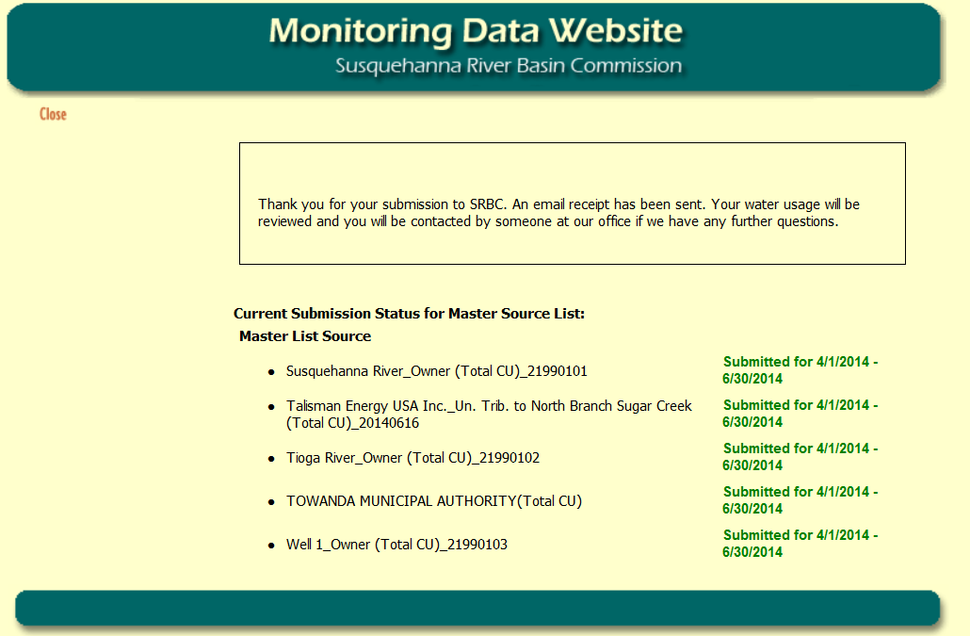

235954.1
View Report Submission Status
To check on the status of your quarterly reporting, return to the home page and click “Report Submission Status”.

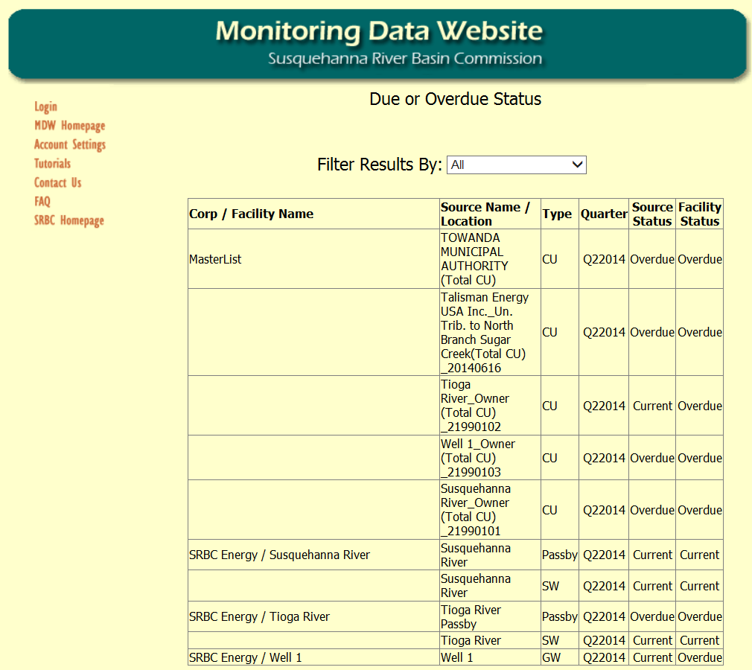

Print Invoice
This will display a list of all outstanding Invoices. In addition, you may choose to unhide and view all paid invoices. To view an Invoice, click on the Invoice Number link. An example Invoice is shown on the following page.

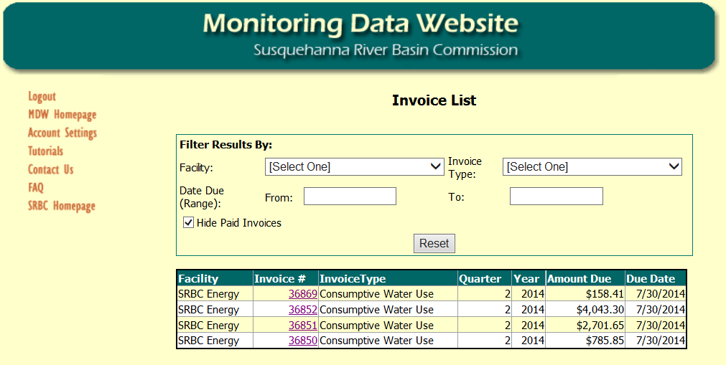

235954.1
Example of an Invoice
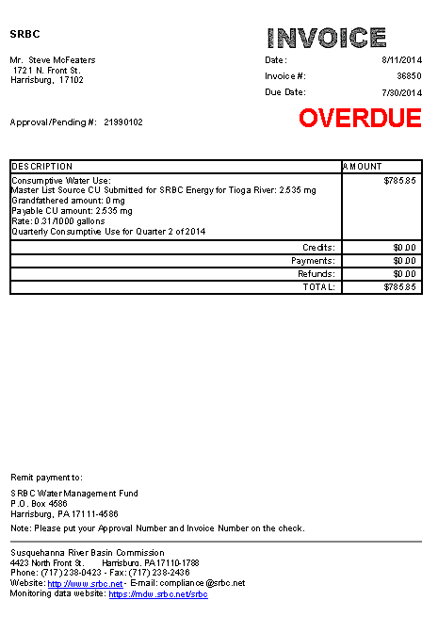

235954.1
Print or Review Monitoring Data
Here you can view all withdrawal data. You can select a Facility, Source, Year, and Quarter. In addition, you can choose to view your consumptive use data reported on your master list sources.

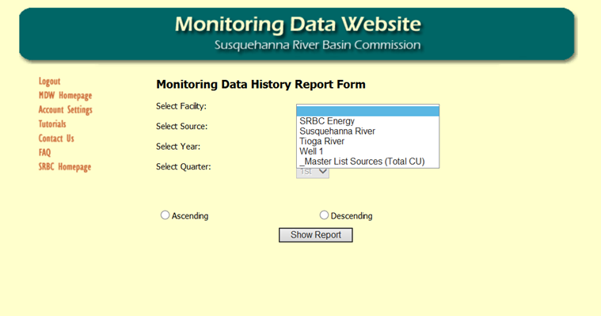

Clicking “Show Report” will display a printable report of the selected data in a new window, as shown below.

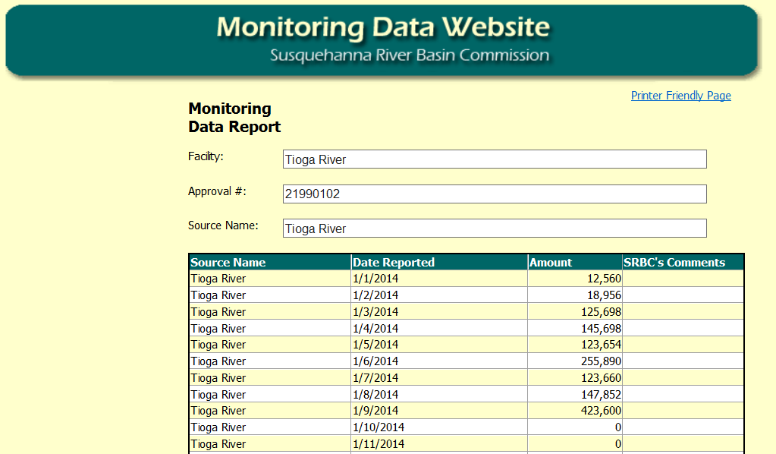

235954.1
Review Withdrawal Exceedance Data
Here you can view all withdrawal exceedances. You can select a Facility, Source, Year, and Quarter.

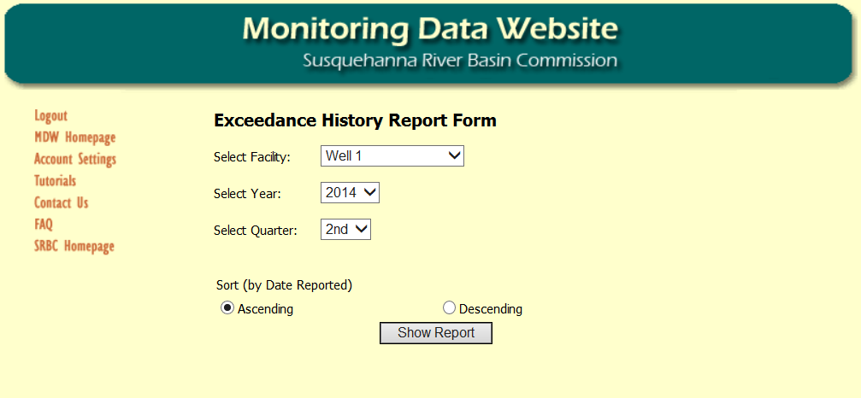

Clicking “Show Report” will display a printable report of the selected data in a new window, as shown below.

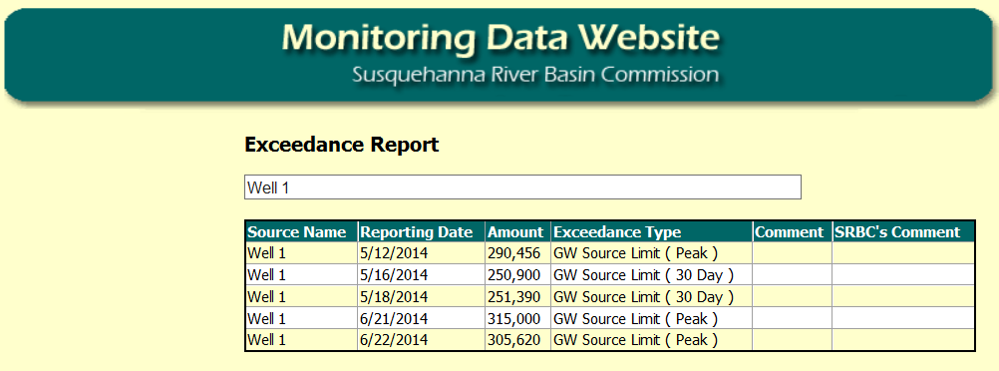

235954.1
Review Passby Data and Exceedances
Here you can view all passby data and/or exceedances. You can select a Facility, Source, Year, and Quarter.

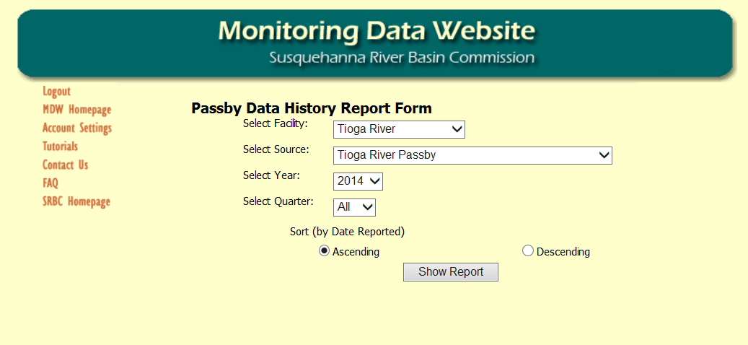

Clicking “Show Report” will display a printable report of the selected data and any exceedances in a new window, as shown below.

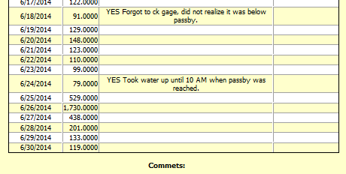

Download Dockets
Clicking this link will display all dockets that are available for download. Dockets may be downloaded by selecting the button next to the docket you wish to download and clicking “Download”. A dialog will appear asking if you wish to open or save the Docket. Note that Dockets are in PDF format and require Adobe Acrobat to view.

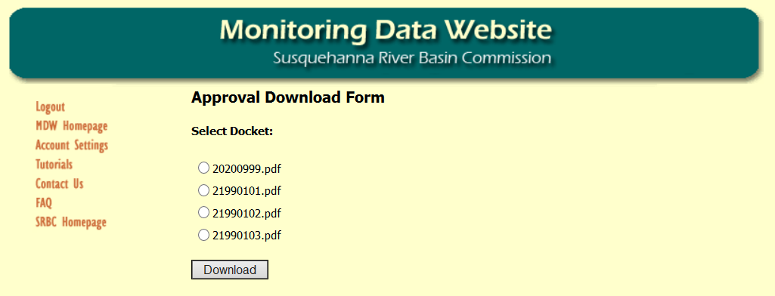
235954.1
Help and Support

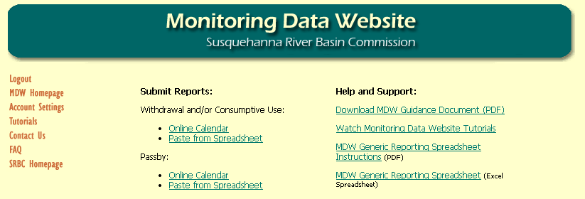
Please select “Download MDW Guidance Document” to view this Guidance Document.

Please select “Watch Monitoring Data Website Tutorials” to view several short instructional videos regarding MDW reporting.

Please select to view “MDW Generic Reporting Spreadsheet Instructions”.

235954.1
Please select to
view “MDW Generic Reporting Spreadsheet”.

You may edit this excel spreadsheet template for your specific reporting needs.

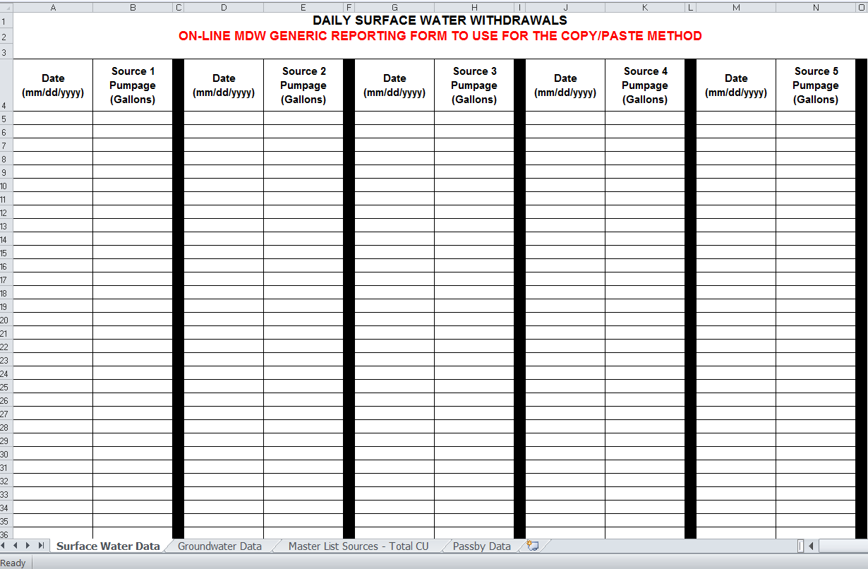

There are separate tabs at the bottom of the spreadsheet that you may choose for your specific reporting needs.

If you have any Monitoring Data Website Questions please contact:

Dorinda Kennedy
570-731-4839 ext. 1500
dkennedy@srbc.net
235954.1

